|  |
| --- |
| The SAS System |

The REG Procedure

Model: MODEL1

Dependent Variable: Crime

|  |  |
| --- | --- |
| **Number of Observations Read** | 47 |
| **Number of Observations Used** | 47 |

| **Analysis of Variance** | | | | | |
| --- | --- | --- | --- | --- | --- |
| **Source** | **DF** | **Sum of Squares** | **Mean Square** | **F Value** | **Pr > F** |
| **Model** | 9 | 5063555 | 562617 | 11.45 | <.0001 |
| **Error** | 37 | 1817373 | 49118 |  |  |
| **Corrected Total** | 46 | 6880928 |  |  |  |

|  |  |  |  |
| --- | --- | --- | --- |
| **Root MSE** | 221.62622 | **R-Square** | 0.7359 |
| **Dependent Mean** | 905.08511 | **Adj R-Sq** | 0.6716 |
| **Coeff Var** | 24.48678 |  |  |

| **Parameter Estimates** | | | | | | | |
| --- | --- | --- | --- | --- | --- | --- | --- |
| **Variable** | **DF** | **Parameter Estimate** | **Standard Error** | **t Value** | **Pr > |t|** | **95% Confidence Limits** | |
| **Intercept** | **1** | -8490.49490 | 1814.99266 | -4.68 | <.0001 | -12168 | -4812.97046 |
| **Time** | **1** | 2.05410 | 6.69661 | 0.31 | 0.7608 | -11.51451 | 15.62272 |
| **Prob** | **1** | -1299.54443 | 2152.01338 | -0.60 | 0.5496 | -5659.93771 | 3060.84886 |
| **M** | **1** | 125.48382 | 35.02674 | 3.58 | 0.0010 | 54.51289 | 196.45474 |
| **Ed** | **1** | 43.32769 | 54.75408 | 0.79 | 0.4338 | -67.61462 | 154.27000 |
| **Po1** | **1** | 75.96214 | 16.72877 | 4.54 | <.0001 | 42.06644 | 109.85784 |
| **MpF** | **1** | 31.69287 | 15.01839 | 2.11 | 0.0417 | 1.26273 | 62.12301 |
| **LF** | **1** | 4800.45379 | 1932.85953 | 2.48 | 0.0177 | 884.10837 | 8716.79921 |
| **splinelf** | **1** | -9176.64432 | 3439.07430 | -2.67 | 0.0112 | -16145 | -2208.41789 |
| **ur** | **1** | 23.93580 | 7.98980 | 3.00 | 0.0049 | 7.74692 | 40.12468 |

|  |
| --- |
| The SAS System |

The REG Procedure

Model: MODEL1

Dependent Variable: Crime

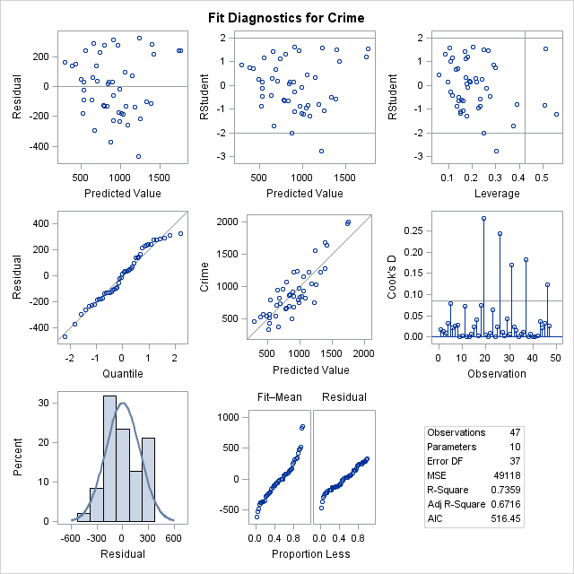

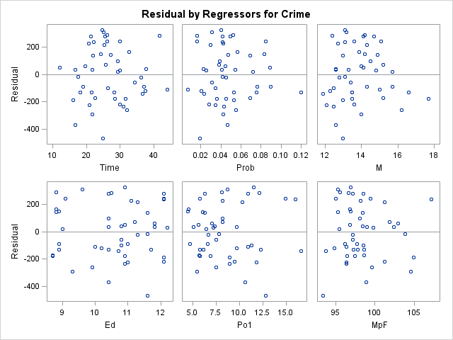

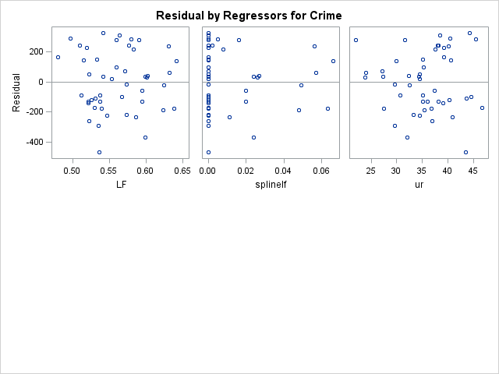

|  |
| --- |
| The SAS System |

The REG Procedure

Model: MODEL1

Dependent Variable: lcrime

|  |  |
| --- | --- |
| **Number of Observations Read** | 47 |
| **Number of Observations Used** | 47 |

| **Analysis of Variance** | | | | | |
| --- | --- | --- | --- | --- | --- |
| **Source** | **DF** | **Sum of Squares** | **Mean Square** | **F Value** | **Pr > F** |
| **Model** | 7 | 5.90958 | 0.84423 | 17.67 | <.0001 |
| **Error** | 39 | 1.86303 | 0.04777 |  |  |
| **Corrected Total** | 46 | 7.77261 |  |  |  |

|  |  |  |  |
| --- | --- | --- | --- |
| **Root MSE** | 0.21856 | **R-Square** | 0.7603 |
| **Dependent Mean** | 6.72494 | **Adj R-Sq** | 0.7173 |
| **Coeff Var** | 3.25004 |  |  |

| **Parameter Estimates** | | | | | | | |
| --- | --- | --- | --- | --- | --- | --- | --- |
| **Variable** | **DF** | **Parameter Estimate** | **Standard Error** | **t Value** | **Pr > |t|** | **95% Confidence Limits** | |
| **Intercept** | **1** | 0.02961 | 1.05241 | 0.03 | 0.9777 | -2.09908 | 2.15830 |
| **Time** | **1** | -0.00642 | 0.00604 | -1.06 | 0.2936 | -0.01863 | 0.00578 |
| **Prob** | **1** | -5.11084 | 2.02675 | -2.52 | 0.0159 | -9.21033 | -1.01136 |
| **M** | **1** | 0.11887 | 0.03530 | 3.37 | 0.0017 | 0.04747 | 0.19026 |
| **Ed** | **1** | 0.23293 | 0.05481 | 4.25 | 0.0001 | 0.12206 | 0.34380 |
| **Po1** | **1** | 0.10074 | 0.01731 | 5.82 | <.0001 | 0.06574 | 0.13575 |
| **ur** | **1** | 0.02235 | 0.00781 | 2.86 | 0.0067 | 0.00656 | 0.03813 |
| **Ineq** | **1** | 0.06943 | 0.01522 | 4.56 | <.0001 | 0.03864 | 0.10022 |

|  |
| --- |
| The SAS System |

The REG Procedure

Model: MODEL1

Dependent Variable: lcrime

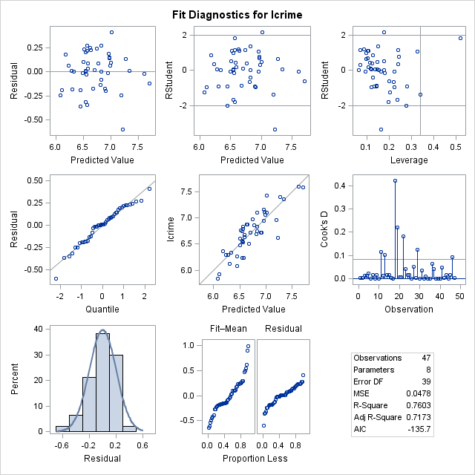

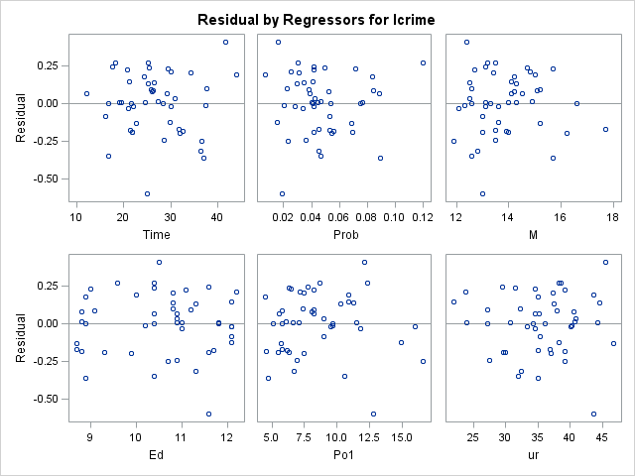

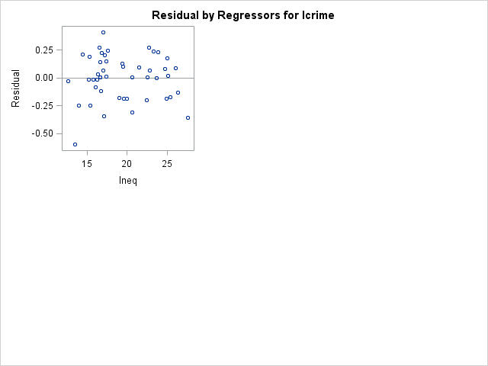

/*Take out ineq*/

**proc** **reg** plots=diagnostics(stats=(default aic));

model crime = time prob m ed po1 mpf lf splinelf ur/clb;

**run**;

**quit**;

/*Take out wealth*/

**proc** **reg** plots=diagnostics(stats=(default aic));

model lcrime = time prob m ed po1 ur ineq/ clb;

**run**;

**quit**;

|  |
| --- |
| The SAS System |

The REG Procedure

Model: MODEL1

Dependent Variable: Crime

|  |  |
| --- | --- |
| **Number of Observations Read** | 47 |
| **Number of Observations Used** | 47 |

| **Analysis of Variance** | | | | | |
| --- | --- | --- | --- | --- | --- |
| **Source** | **DF** | **Sum of Squares** | **Mean Square** | **F Value** | **Pr > F** |
| **Model** | 9 | 5406872 | 600764 | 15.08 | <.0001 |
| **Error** | 37 | 1474056 | 39839 |  |  |
| **Corrected Total** | 46 | 6880928 |  |  |  |

|  |  |  |  |
| --- | --- | --- | --- |
| **Root MSE** | 199.59795 | **R-Square** | 0.7858 |
| **Dependent Mean** | 905.08511 | **Adj R-Sq** | 0.7337 |
| **Coeff Var** | 22.05295 |  |  |

| **Parameter Estimates** | | | | | | | |
| --- | --- | --- | --- | --- | --- | --- | --- |
| **Variable** | **DF** | **Parameter Estimate** | **Standard Error** | **t Value** | **Pr > |t|** | **95% Confidence Limits** | |
| **Intercept** | **1** | -7172.70762 | 1505.61901 | -4.76 | <.0001 | -10223 | -4122.03373 |
| **Time** | **1** | 2.52384 | 6.00744 | 0.42 | 0.6768 | -9.64838 | 14.69606 |
| **Prob** | **1** | -2729.13866 | 1965.35831 | -1.39 | 0.1733 | -6711.33287 | 1253.05554 |
| **M** | **1** | 70.44073 | 32.08886 | 2.20 | 0.0345 | 5.42251 | 135.45895 |
| **Ed** | **1** | 116.19199 | 55.03385 | 2.11 | 0.0416 | 4.68282 | 227.70116 |
| **Po1** | **1** | 119.43420 | 13.57289 | 8.80 | <.0001 | 91.93292 | 146.93548 |
| **MpF** | **1** | 22.06995 | 13.57856 | 1.63 | 0.1126 | -5.44282 | 49.58273 |
| **LF** | **1** | 2844.43954 | 1757.38505 | 1.62 | 0.1140 | -716.36080 | 6405.23988 |
| **splinelf** | **1** | -7433.38673 | 3102.94789 | -2.40 | 0.0218 | -13721 | -1146.21709 |
| **Ineq** | **1** | 63.77271 | 14.37453 | 4.44 | <.0001 | 34.64715 | 92.89827 |

|  |
| --- |
| The SAS System |

The REG Procedure

Model: MODEL1

Dependent Variable: Crime

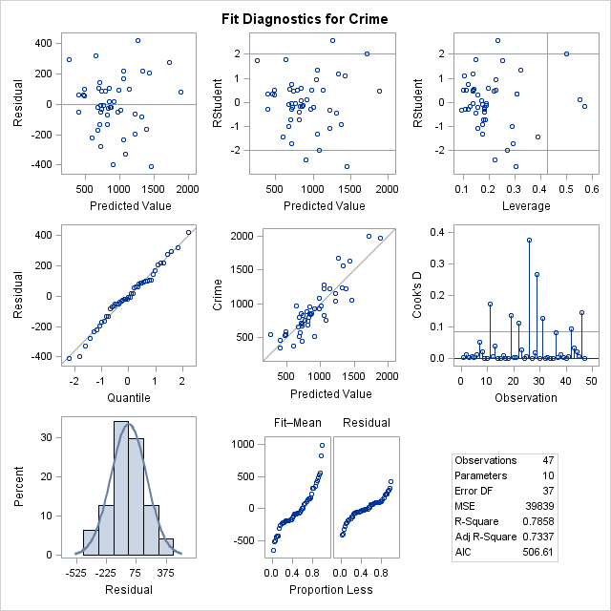

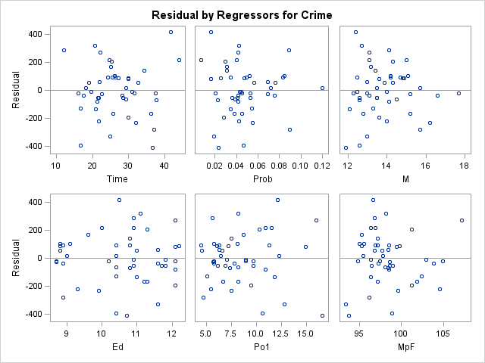

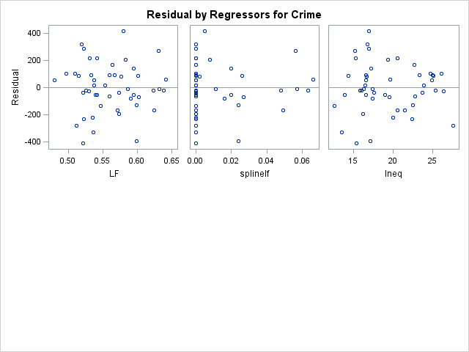

|  |
| --- |
| The SAS System |

The REG Procedure

Model: MODEL1

Dependent Variable: lcrime

|  |  |
| --- | --- |
| **Number of Observations Read** | 47 |
| **Number of Observations Used** | 47 |

| **Analysis of Variance** | | | | | |
| --- | --- | --- | --- | --- | --- |
| **Source** | **DF** | **Sum of Squares** | **Mean Square** | **F Value** | **Pr > F** |
| **Model** | 7 | 5.73087 | 0.81870 | 15.64 | <.0001 |
| **Error** | 39 | 2.04174 | 0.05235 |  |  |
| **Corrected Total** | 46 | 7.77261 |  |  |  |

|  |  |  |  |
| --- | --- | --- | --- |
| **Root MSE** | 0.22881 | **R-Square** | 0.7373 |
| **Dependent Mean** | 6.72494 | **Adj R-Sq** | 0.6902 |
| **Coeff Var** | 3.40236 |  |  |

| **Parameter Estimates** | | | | | | | |
| --- | --- | --- | --- | --- | --- | --- | --- |
| **Variable** | **DF** | **Parameter Estimate** | **Standard Error** | **t Value** | **Pr > |t|** | **95% Confidence Limits** | |
| **Intercept** | **1** | 0.17759 | 1.17030 | 0.15 | 0.8802 | -2.18956 | 2.54474 |
| **Time** | **1** | -0.00456 | 0.00626 | -0.73 | 0.4700 | -0.01722 | 0.00809 |
| **Prob** | **1** | -4.21605 | 2.14789 | -1.96 | 0.0568 | -8.56057 | 0.12847 |
| **M** | **1** | 0.11236 | 0.03692 | 3.04 | 0.0042 | 0.03769 | 0.18703 |
| **Ed** | **1** | 0.13525 | 0.05228 | 2.59 | 0.0135 | 0.02951 | 0.24100 |
| **Po1** | **1** | 0.10362 | 0.01921 | 5.39 | <.0001 | 0.06476 | 0.14248 |
| **Wealth** | **1** | 0.00021275 | 0.00010553 | 2.02 | 0.0507 | -7.07798E-7 | 0.00042622 |
| **Ineq** | **1** | 0.09706 | 0.01991 | 4.88 | <.0001 | 0.05679 | 0.13732 |

|  |
| --- |
| The SAS System |

The REG Procedure

Model: MODEL1

Dependent Variable: lcrime

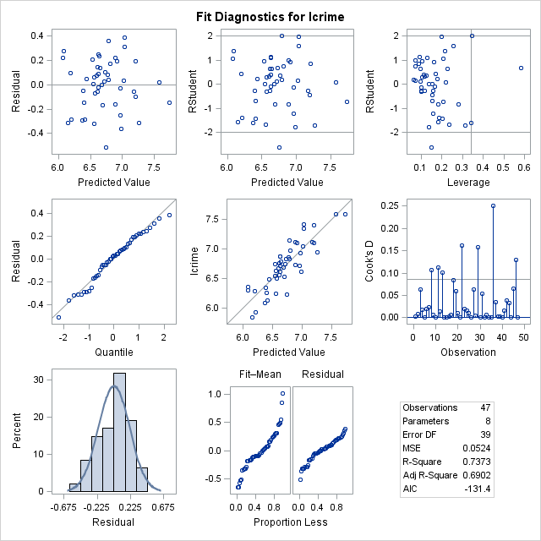

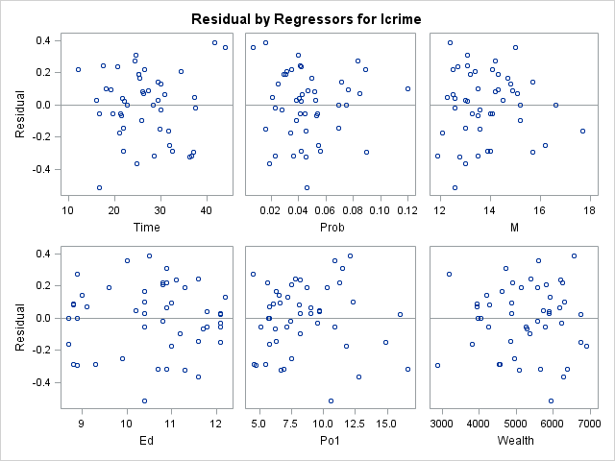

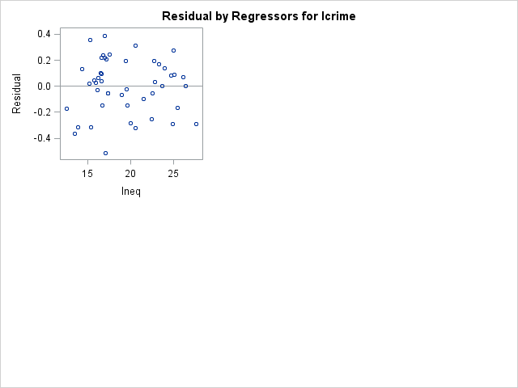

/*Take out ur*/

**proc** **reg** plots=diagnostics(stats=(default aic));

model crime = time prob m ed po1 mpf lf splinelf ineq/clb;

**run**;

**quit**;

**proc** **reg** plots=diagnostics(stats=(default aic));

model lcrime = time prob m ed po1 wealth ineq/ clb;

**run**;

**quit**;